CS-340 Project Two: Interactive Dashboard

Project Overview
The purpose of this project was to design and implement an interactive, client-facing dashboard for Grazioso Salvare using MongoDB and Dash. The dashboard allows users to explore and filter animal shelter data from the Austin Animal Center to identify dogs that meet specific rescue criteria. The application supports multiple rescue scenarios and presents data visually through charts and geolocation mapping.
This project demonstrates client/server development principles, database integration, and interactive data visualization.

Technologies Used
The following tools and technologies were used to complete this project:
- MongoDB: Stores and manages the Austin Animal Center dataset.
- PyMongo: Enables Python-based interaction with the MongoDB database.
- Python: Core programming language used for data processing and application logic.
- Dash (Plotly): Used to build the interactive web-based dashboard.
- Pandas: Used to manipulate and format MongoDB query results.
- Dash Leaflet: Used to display geolocation data on an interactive map.
- JupyterDash: Allows the dashboard to run inside the Jupyter notebook environment.

Dashboard Functionality
The dashboard provides users with the ability to filter animal shelter data using predefined rescue categories. A set of radio button controls allows users to switch between rescue types, and all visual components update dynamically based on the selected filter.

Supported Rescue Filters
- Reset (All)
Displays all animals in the database with no filtering applied.
- Water Rescue
Filters dogs based on breed, sex, and age requirements suitable for water rescue operations.
- Mountain or Wilderness Rescue
Filters dogs suited for wilderness and mountain rescue scenarios.
- Disaster or Individual Tracking
Filters dogs appropriate for disaster response and individual tracking situations.
Each filter applies a MongoDB query that selects animals matching the specific rescue criteria.

Interactive Data Table
The data table displays detailed information for each animal, including breed, age, outcome status, and location data. The table supports:
- Pagination
- Sorting
- Column filtering
- Single-row selection
Selecting a row highlights the entry and updates the geolocation map accordingly.

Data Visualization
The dashboard includes two dynamic visual components:
- Bar Chart
Displays the most common breeds within the currently selected rescue filter, helping users quickly identify breed distribution.
- Geolocation Map
Shows the location of the selected animal using latitude and longitude coordinates. When a user selects a different row in the table, the map updates to reflect the new animal’s location.
These visualizations help users interpret the data more efficiently and support informed decision-making.

Screenshots and Validation
The following screenshots are included to demonstrate functionality:
- Initial dashboard load (Reset All)
- Water Rescue filter applied
- Mountain or Wilderness Rescue filter applied
- Disaster or Individual Tracking filter applied
- Reset All filter reapplied
Each screenshot shows the active filter, data table, chart, map, logo, and developer name.
Screenshot: Initial load (Reset All)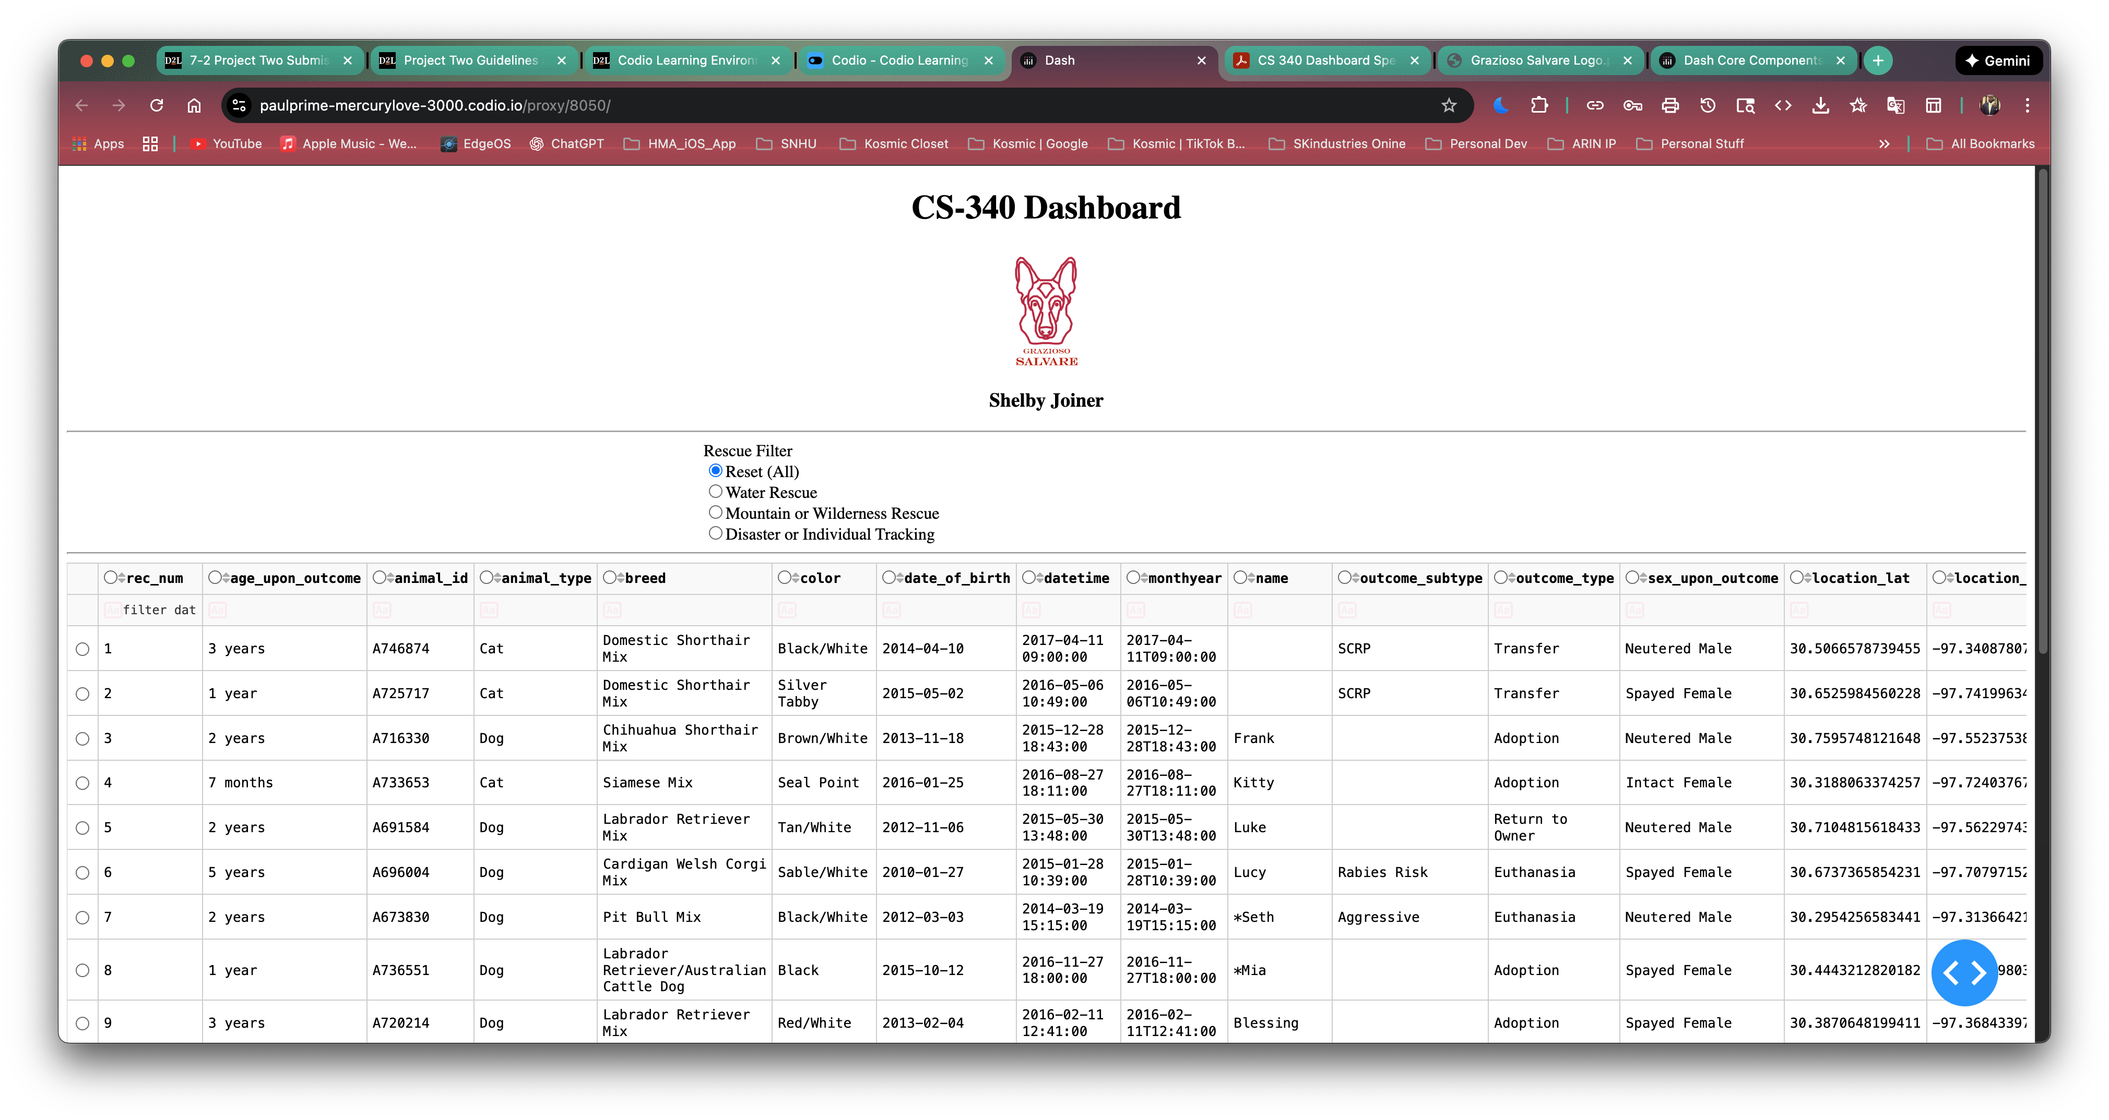
Screenshot: Water Rescue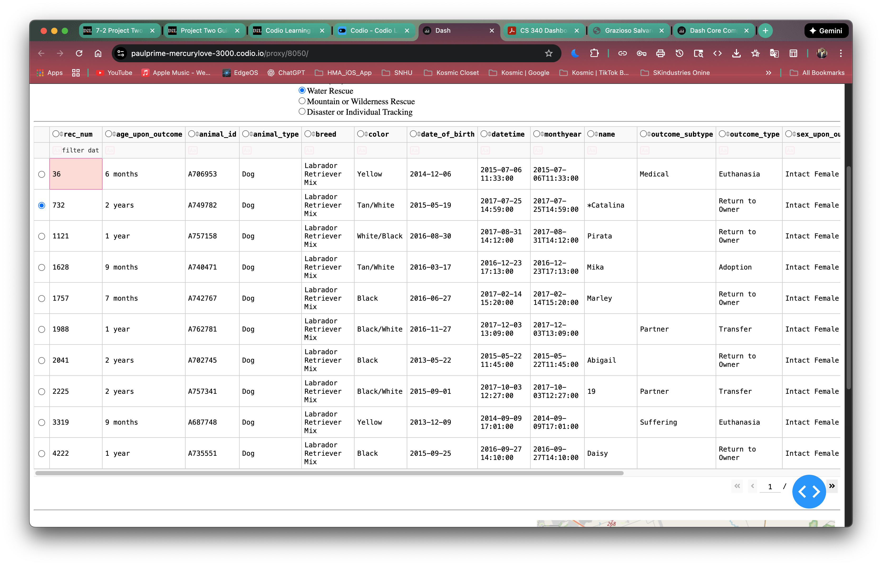

Screenshot: Mountain or Wilderness Rescue selected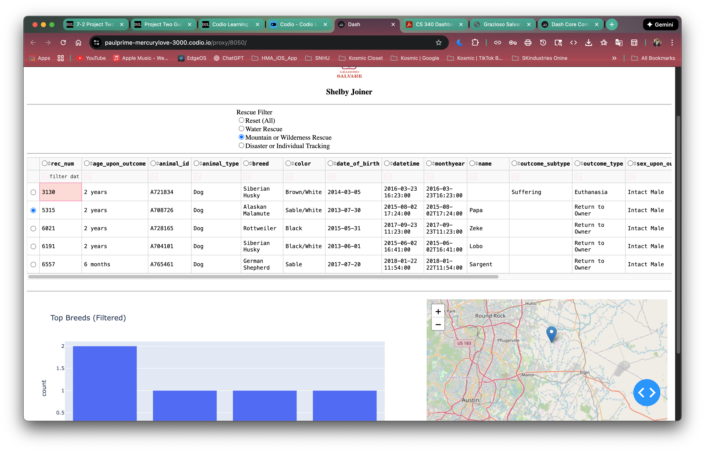Screenshot Disaster or individual tracking
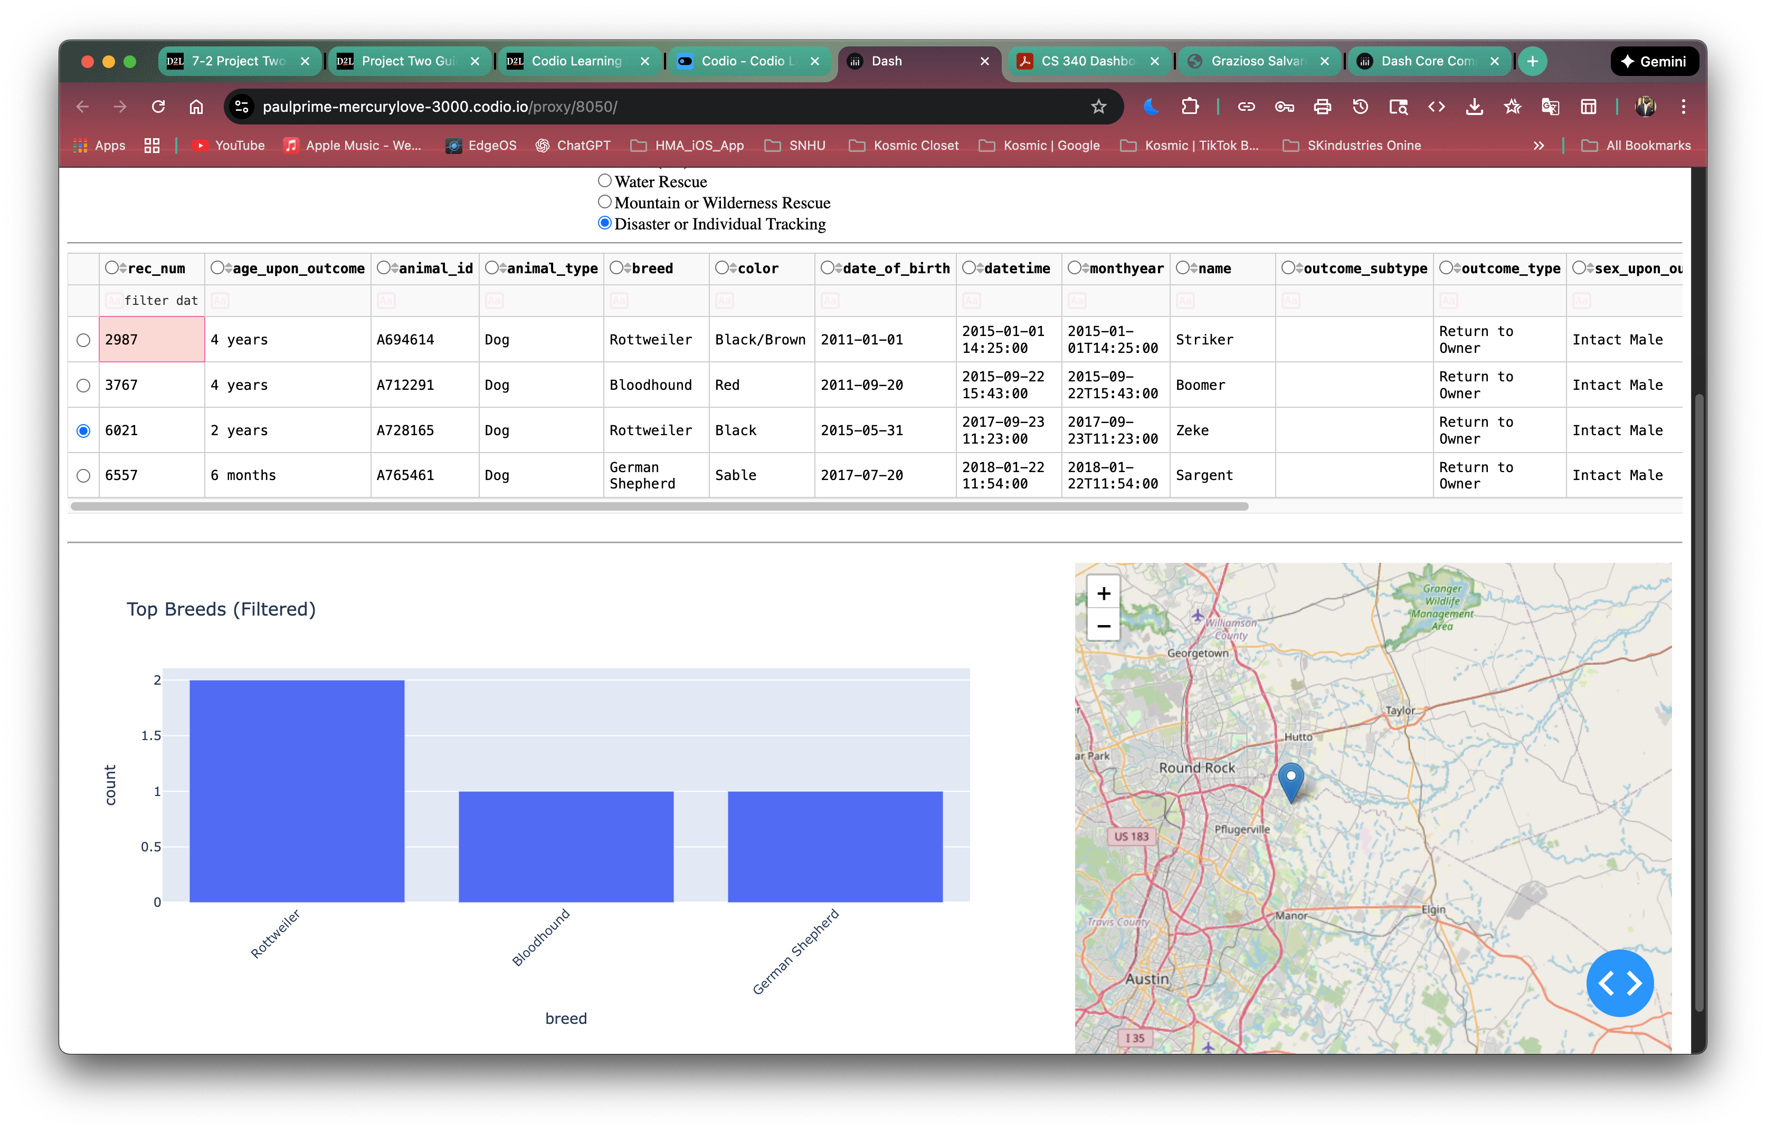
Screenshot: Reset All
